Soho F208 PBX

User Manual
Designed for family, small business & home office

Authorized Agent in North America:
Pinetree Eletronics Ltd
9180 Wellmond Road
Richmond, BC V7E 1L5
Canada
Tel: 604-2821293

Installation/Connection Graph:

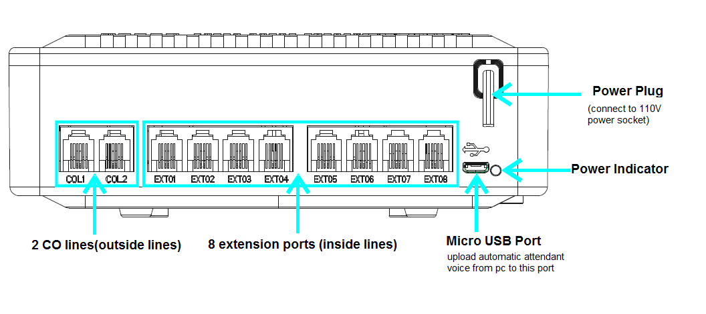

Feature Highlights

- Flexsible extension device requirment

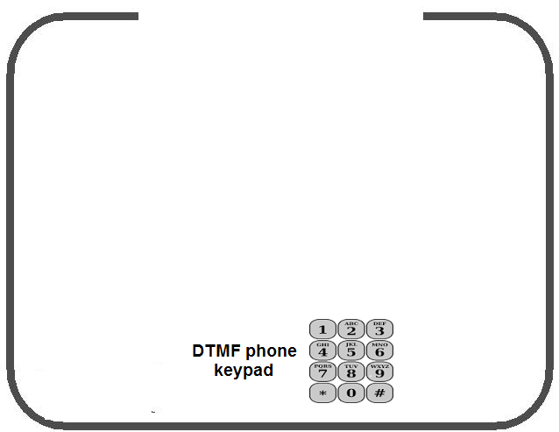
Save money on phone

Unlike other phone systems which require expensive and customized phone set . F208 can accept any DTMF phone as extension. You can use your existing home phone or cordless phone as extension which can save lots of your investment.

Over 99% phone set in the market support DTMF. A typical DTMF keypad is as following:
.

2 Automated attendant Built-in Voice(BV)

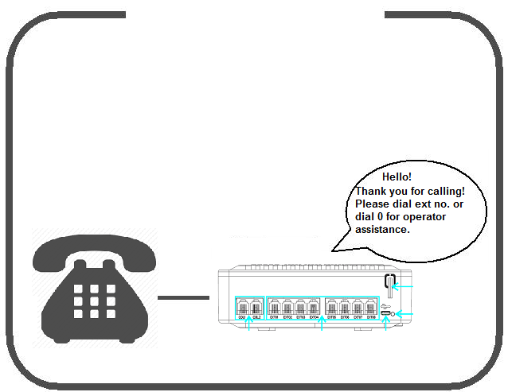
Auto Attendant BV

The customizable Automated attendant BV can help incoming caller to connect a specific extension directly or ask for operator for assistance.

Message | Message | Message
Message | Message | Message

3 .Incoming call transfer
Incoming call transfer

Incoming call to any extension can be transfered to any other extension easily.

Message | Message
Message | Message

4. Secretary assisted dialing
Secretary assisted dialing

A secretary can make outgoing calls from any extension and then transfer the call to another extension. .

5. Flexible Caller ID display
Caller ID display
F208 PBX support both DTMF and FSK
dual-format incoming Caller ID display.
Note: In order to display caller ID, your
phone set should support caller ID display
function

6 Flexible outgoing calling
Flexible outgoing call

Default outgoing call prefix is “9”
This PBX also support direct outgoing call without any prefix.
If the system is set as direct outgoing call without prefix, inside call(extensions call each other)should add a prefix # before extension number.

7 Flexible incoming ringing
Flexible incoming ringing

F208 PBX allows incoming call ringing on any selected extension or ringing on all extensions. Check configuration guide in next chapter.
Default incoming call rings on extension 01

8 Restricting outgoing calls

Restricting outgoing calls

3-l

 | 3-level
 | DISA
 | OGM 22
 | 3-level |  |  |  |  | Dial 0
 | DISA |  |  |  |  | (Mike)
7 | OGM 23 |  |  |  |  | Dial 1
8
 | 3-level |  |  |  |  | (John)
 | DISA |  |  |  |  | Dial 2
 | OGM 24
 |  |  |  |  |  | (Tony)

Long-distance prefix dialing can be disabled on
any extension by restricting the dialing of certain
prefix patterns.

Chapter 1 Important Information

WARNING

- THIS UNIT MAY ONLY BE INSTALLED AND SERVICED BY QUALIFIED SERVICE PERSONNEL.

- IF DAMAGE TO THE UNIT EXPOSES ANY INTERNAL PARTS, DISCONNECT THE POWER SUPPLY CORD IMMEDIATELY AND RETURN THE UNIT TO YOUR DEALER

- UNPLUG THIS UNIT FROM THE AC OUTLET IF IT EMITS SMOKE, AN
ABNORMAL SMELL OR MAKES UNUSUAL NOISE. THESE CONDITIONS CAN CAUSE FIRE OR ELECTRIC SHOCK. CONFIRM THAT SMOKE HAS STOPPED AND CONTACT AN AUTHORIZED PANASONIC FACTORY SERVICENTER.

- WHEN RELOCATING THE EQUIPMENT, FIRST DISCONNECT THE TELECOM CONNECTION BEFORE DISCONNECTING THE POWER CONNECTION. WHEN THE UNIT IS INSTALLED IN THE NEW LOCATION, RECONNECT THE POWER FIRST, AND THEN RECONNECT THE TELECOM CONNECTION.

- THIS UNIT IS EQUIPPED WITH A GROUNDING CONTACT PLUG. FOR SAFETY REASONS THIS PLUG MUST ONLY BE CONNECTED TO A GROUNDING CONTACT SOCKET THAT HAS BEEN INSTALLED ACCORDING TO APPLICABLE REGULATIONS.

- TO PREVENT POSSIBLE FIRE OR ELECTRIC SHOCK, DO NOT EXPOSE THIS PRODUCT TO RAIN OR MOISTURE.

- THE POWER SUPPLY CORD IS USED AS THE MAIN DISCONNECT DEVICE. ENSURE THAT THE AC OUTLET IS LOCATED NEAR THE EQUIPMENT AND IS EASILY ACCESSIBLE.

- TO PROTECT THIS UNIT FROM STATIC ELECTRICITY, DO NOT TOUCH ANY EXTERNAL CONNECTORS OF THE UNIT.

IMPORTANT SAFETY INSTRUCTIONS

When using your telephone equipment, basic safety precautions should always be followed to reduce the risk of fire, electric shock and injury to persons, including the following:

- Read and understand all instructions.

- Follow all warnings and instructions marked on the product.

- Unplug the product from the wall outlet before cleaning. Do not use liquid cleaners or aerosol cleaners. Clean with a damp cloth.

- Do not use this product near water, for example, near a bathtub, wash bowl, kitchen sink, or laundry tub, in a wet basement, or near a swimming pool.

- Do not place the product on an unstable surface, as a fall may cause serious internal damage.

- Slots and openings in the front, back and bottom of the cabinet are provided for ventilation; to protect it from overheating, these openings must not be blocked or covered. The openings should never be blocked by placing the product on a bed, sofa, rug, or other similar surface while in use. The product should never be placed near or over a radiator or other heat source. This product should not be placed in a sealed environment unless proper ventilation is provided.

- The product should only be connected to the type of electrical power supply specified on the product label. If you are not sure of the type of power supply to your home, consult your dealer or local power company.

- For safety purposes this unit is equipped with a grounded plug. If you do not have a grounded outlet, please have one installed. Do not bypass this safety feature by tampering with the plug.

- Do not allow anything to rest on the power cord. Do not locate this product where the power cord may be stepped on or tripped on.

- To reduce the risk of fire or electric shock, do not overload wall outlets and extension cords.

- Do not insert objects of any kind into this product through its slots and openings, as they may touch dangerous voltage points or short out parts that could result in a risk of fire or electric shock. Never spill liquid of any kind on or in the product.

- To reduce the risk of electric shock, do not disassemble this product. Only qualified personnel should service this product. Opening or removing covers may expose you to dangerous voltages or other risks. Incorrect reassembly can cause electric shock.

- Unplug this product from the wall outlet and have it serviced by qualified service personnel in the following cases:

  - When the power supply cord or plug is damaged or frayed.

  - If liquid has been spilled into the product.

  - If the product has been exposed to rain or water.

  - If the product does not operate according to the operating instructions. Adjust only the controls that are explained in the operating instructions. Improper adjustment of other controls may result in damage and may require service by a qualified technician to restore the product to normal operation.

  - If the product has been dropped or the cabinet has been damaged.

  - If product performance deteriorates.

- Avoid using wired telephones during an electrical storm. There is a remote risk of electric shock from lightning.

- Do not use a telephone in the vicinity of a gas leak to report the leak.

SAVE THESE INSTRUCTIONS

Operating Manual 5

Attention

- Keep the unit away from heating appliances and devices that generate electrical noise such as fluorescent lamps, motors, and televisions. These noise sources can interfere with the performance of the PBX.

- This unit should be kept free of dust, moisture, high temperature (more than 40 °C [104 °F]), and vibration, and should not be exposed to direct sunlight.

- If you are having problems making calls to outside destinations, follow this procedure to test the outside (CO) lines:

  - Disconnect the PBX from all outside (CO) lines.

  - Connect known working single line telephones (SLTs) to those outside (CO) lines.

  - Make a call to an external destination using those SLTs.

If a call cannot be carried out correctly, there may be a problem with the outside (CO) line that the SLT is connected to. Contact your telephone company.

If all SLTs operate properly, there may be a problem with your PBX. Do not reconnect the PBX to the outside (CO) lines until it has been serviced by an authorized Panasonic Factory Servicenter.

- Wipe the unit with a soft cloth. Do not clean the unit with abrasive powders or with chemical agents such as benzene or thinner.

- When using a Panasonic proprietary telephone (PT), use only the correct Panasonic handset.

When you ship the product

Carefully pack and send it prepaid, adequately insured and preferably in the original carton. Attach a postage-paid letter, detailing the symptom, to the outside of the carton. DO NOT send the product to the Executive or Regional Sales offices. They are NOT equipped to make repairs.

Product Service

Panasonic Factory Servicenters for this product are listed in the servicenter directory. Consult your certified Panasonic dealer for detailed instructions.

For Future Reference

Please print, record, and retain the following information for future reference.

Note

The serial number of this product can be found on the label affixed to the unit. You should record the model number and the serial number of this unit as a permanent record of your purchase to aid in identification in the event of theft.

MODEL NO.

SERIAL NO.

DATE OF PURCHASE

NAME OF DEALER

DEALER'S ADDRESS

DEALER'S TEL. NO.

F.C.C. REQUIREMENTS AND RELEVANT INFORMATION

- Notification to the Telephone Company

This equipment complies with Part 68 of the FCC rules and the requirements adopted by the ACTA. On the side of this equipment is a label that contains, among other information, a product identifier in the format US: ACJMF04BKX-TA824. If requested, this number must be provided to the telephone company.

Installation must be performed by a qualified professional installer. If required, provide the telephone company with the following technical information:

  - Telephone numbers to which the system will be connected

  - Make: Cesller

  - Model: SOHO-F208

  - Certification No.: found on the side of the unit

  - Ringer Equivalence No.: 0.4B

  - Facility Interface Code: 02LS2

  - Service Order Code: 9.0F

  - Required Network Interface Jack: RJ11

- Ringer Equivalence Number (REN)

The REN is used to determine the number of devices that may be connected to a telephone line. Excessive RENs on a telephone line may result in the devices not ringing in response to an incoming call. In most, but not all areas, the sum of RENs should not exceed five (5.0). To be certain of the number of devices that may be connected to a line, as determined by the total RENs, contact the local telephone company. The REN for this product is part of the product identifier that has the format US: ACJMF04BKX-TA824. The digits represented by 04 are the REN without a decimal point (e.g., 04 is a REN of 0.4). For earlier products, the REN is separately shown on the label.

- Incidence of Harm to the Telephone Lines

If this equipment causes harm to the telephone network, the telephone company will notify you in advance that temporary discontinuance of service may be required. But if advance notice isn't practical, the telephone company will notify the customer as soon as possible. Also, you will be advised of your right to file a complaint with the FCC if you believe it is necessary.

- Changes in Telephone Company Communications Facilities, Equipment, Operations and Procedures

The telephone company may make changes in its facilities, equipment, operations or procedures that could affect the operation of the equipment. If this happens the telephone company will provide advance notice in order for you to make necessary modifications to maintain uninterrupted service.

- Trouble with this equipment

If trouble is experienced with this equipment, for repair or warranty information, please see the attached warranty, which includes the Servicenter Directory. If the equipment is causing harm to the telephone network, the telephone company may request that you disconnect the equipment until the problem is resolved.

- Connection to Party Line

Connection to party line service is subject to state tariffs. Contact the state public utility commission, public service commission or corporation commission for information.

8 Operating Manual

- Combined Use with Alarm Equipment

If your home has specially wired alarm equipment connected to the telephone line, ensure the installation of this equipment does not disable your alarm equipment. If you have questions about what will disable alarm equipment, consult your telephone company or a qualified installer.

Note

This equipment has been tested and found to comply with the limits for a Class B digital device, pursuant to Part 15 of the FCC Rules. These limits are designed to provide reasonable protection against harmful interference in a residential installation. This equipment generates, uses, and can radiate radio frequency energy and, if not installed and used in accordance with the instructions, may cause harmful interference to radio communications. However, there is no guarantee that interference will not occur in a particular installation. If this equipment does cause harmful interference to radio or television reception, which can be determined by turning the equipment off and on, the user is encouraged to try to correct the interference by one or more of the following measures:

- Reorient or relocate the receiving antenna.

- Increase the separation between the equipment and receiver.

- Connect the equipment into an outlet on a circuit different from that to which the receiver is connected.

- Consult the dealer or an experienced radio/TV technician for help.

CAUTION

Any changes or modifications not expressly approved by the party responsible for compliance could void the user's authority to operate this device.

When programming emergency numbers and/or making test calls to emergency numbers:

- Remain on the line and briefly explain to the dispatcher the reason for the call before hanging up.

- Perform such activities in the off-peak hours, such as early morning hours or late evenings.

WARNING

The software contained in the TRS feature to allow user access to the network must be upgraded to recognize newly established network area codes and exchange codes as they are placed into service. Failure to upgrade the premises PBXs or peripheral equipment to recognize the new codes as they are established will restrict the customer and the customer's employees from gaining access to the network and to these codes.

KEEP THE SOFTWARE UP-TO-DATE WITH THE LATEST DATA.

Chapter 2

Operation

This chapter shows you step by step how to use each feature. Read this chapter to become familiar with the many useful features of this PBX.

2.1 Before Operating a Telephone

2.1 Before Operating a Telephone

What Kind of Telephone Can Be Used?

You can use a single line device such as a single line telephone (SLT), fax machine, modem, or cordless telephone which accept DTMF ringing mode. To verify if your phone set is DTMF mode, just check if the keypad has feature key “#” and “*”. If yes, then your phone set supports DTMF.

If you use an SLT that does not have the "" or "#" keys,
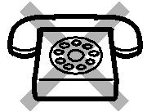
it is not possible to access features that have "" or "#" in their feature numbers which are required by many functions of F208 PBX.

l

  - Basic Operations

  - Basic Operations

2.2.1 Making Calls

– Inside Call (Extension calling Extension)

– Call Outside (CO) Line

Internal Call

You can call another extension as per following instruction.
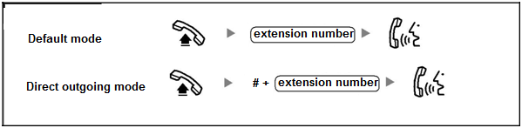
PT

OR

.

.

Read section 2.4.2 and learn how to customize outgoing mode
Default Extension Port vs Extension number list:
Port Extension No.
Ext 01 801
Ext 02 802
Ext 03 803
Ext 04 804
Ext 05 805
Ext 06 806
Ext 07 807
Ext 08 808
You can customize extension number for each port, see Section 2.4.1

Line Access, Outside (CO) Line

You can call an outside party using one of following Outside (CO) Line Access methods:

1.2 Basic Operations

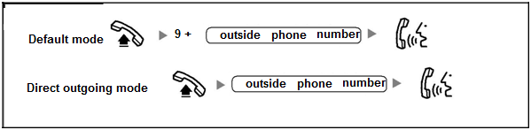
PT/SLTCada

OR

Read Section 2.4.2 to customize outgoing mode

    - Receive Calls

When your extension rings
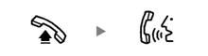

Off-hook Talk

If other extension rings and you want pickup the call from your extension:

Off-hook press * Talk
OR
Off-hook press ##4 + ext. No. Talk

Example: If extension 804 is ringing, and you want to pickup the
Call, pickup your handset, press ##4804 ,you will get the call
talk .

.

1.3 Frequent Used Operations

2.3 Frequently Used Operations o graph

2.3.1 Call Transfer
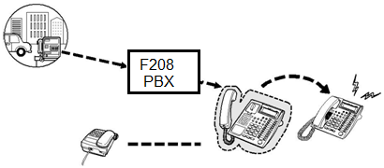
Call Transfer is commonly used by operator. When someone has received a call and wants to transfer the call to another extension,see following demo graph:

To do call Transfer, check following guide:
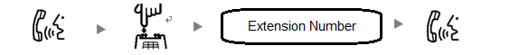

getting a call Tap the hook dial ext No. to be transfered receive transfered call

TAP means push the hook switch and then release it quickly(press no more than 1 second）
Example: You get a call and transfer it to 802 extension, you should tap the hook, then press 802 .

2.3.2 Secretary assisted outgoing call
Sometime you might help other extension to make an outside call or ask your secretary to help you dial a outside call. This operation can be done as per following guide:

Call extension you want help after connected,TAP hook then dial outside phone no. after get connected,hang up
TAP means push the hook switch and then release it quickly(press no more than 1 second）
Example: you are in extension 802 and you want to help extension 804 to call outside no.1-800-9874321
1st step : pickup you phone dial 804 ,after get connected with 804, TAP the hook.
2nd step : from extension 802 dial 9+18009874321 (9 is prefix to call outside)
3rd step :after get connected to 1-800-9874321 then hang up
Finally extension 804 will get to talk with outside line.

2.3.3 Call hold and retrieve
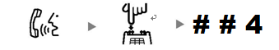
You can hold an incoming call, then talk to other extension and retrieve this call back later after you finish talking with other extension. These two operations are called “Call hold” and “Call retrieve”
Call hold operation:

Talk TAP hook after hearing dialing tone, press ##4
TAP means push the hook switch and then release it quickly.

Call retrieve operation:
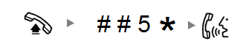

off hook press ##5* talk

Example: You are in ext 801 and get an incoming call from customer, you need ask your assistant (in ext 802) something in order to help your customer, you can operate as following:
In extension 801, tell your customer not hang up the phone ,then TAP hook ,after hearing dialing tone, press ##4(your customer will hear some ringing which means hold)
Hang up phone , then pickup and dial 802 and talk to your assistant. After finishing talking with 802, hang up phone and pickup again, dial ##5*, you can get connected with your customer again.
2.3.3 Automatic Callback Busy (Camp-on)

If a dialed extension or a desired outside (CO) line is busy, you can set the Automatic Callback Busy feature. Then, when the extension or outside (CO) line becomes idle, your telephone will ring automatically. When you answer the callback ring:

- a dialed extension becomes idle.

- a desired outside (CO) line that is in use by another extension becomes idle. You cannot set Automatic Callback Busy for a busy party outside of the PBX.

When you answer the callback ring:

- for an outside (CO) line call: the line is seized.

- for an intercom call: the called extension starts ringing automatically.

To set for both an outside (CO) line call and an intercom call
Demo

While hearing a busy tone

6
C.Tone

Enter 6. On-hook

To answer a callback ring set for a busy extension
Demo

While hearing a callback ring

R.B.Tone

Off-hook. Talk.

To answer a callback ring set for a busy outside (CO) line
Demo

While hearing a callback ring

D.Tone

outside phone no.

Off-hook. Dial outside phone Talk.

2.3.4 Do Not Disturb (DND)

You can set your telephone to prevent incoming calls from ringing at your telephone. This can be useful in situations where you do not want to be disturbed, for example during a meeting.
To set DND:

Off-hook Dial ##7110# Hang up
2.3.5 Cancel Do not disturb(DND), please see section 2.3.7

2.3.6 Call forwarding on (Busy, No answer, Busy or No answer, Allways)
Sometimes you might set a standby extension when your extension is busy or no answer. This is called “Call Forwarding”.
To set forwarding when your extension is busy:

To set forwarding when your extension does not answer:

To set forwarding when your extension is busy or does not answer:

To set forwarding all the time
Example, if you want forward call to ext. 802 when ext 801 is busy, you can off hook ext 801, press ##718022# then hang up.
2.3.7 Cancel Do not disturb(DND) and Call Forwarding
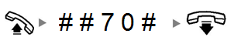

PT
Off-hook dial ##70# on hook.

2.3.8 Hotline (Pickup Dialing)

user can make a call simply by going off-hook, if the telephone number has been stored beforehand. This feature is also known as Pickup Dialing
time means hotline starting time can be 1 to 9 seconds
Example:
If you want to set extension 801 pickup dialing to 805 if 801 has no action in 2 seconds. Please pickup extension 801, dial ## 7612805# , then hang up
2.3.9 Cancel Hotline
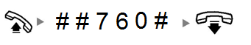

2.4 Setting and customsize F802 PBX

2.4.1 Customize Extension number
Our factory default extension number for each ext port(01 – 08) is prefix 8 + port number.
for example ext port 01 extension number is 801, port 02 number is 802 and so on...
You can customize the extension number of any port, here is the operation:

Port No. means ext port no., it can be from 01 to 08(stands for port no.) or 00 stands for all ports
Extension No. means the extension number you want to assign to the ext port.
Example:
If you want assign 999 to ext port 02(default extension number 802), you can do as following:
Pickup phone set on port 01, dial ##7871967590 1 02 *1* 999#, hang up
2.4.2 Direct outgoing setting
Every extension has two outgoing mode to call outside phone number:
Default outgong mode: Dial prefix “9” + outside phone number
Direct outgoing mode: Dial outside number without prefix
u can select either mode on a specific extension as following:
Port No. means ext port no, it can be from 01 to 08(stands for ext port no.) or 00 stands for all ports
mode can be 0 or 1, “0” stands for dial prefix 9 for outgoing call, 1 stands direct outgoing(no prefix)
Factory default mode is 0
Example:
If you want set all extension to direct outgoing mode without dialing 9 to call outside, do following:
Pickup ext 01 phone set , dial dial ##7871967590 1 * 00 *2* 1# , hang up

2.4.3 Outgoing Call Restriction
You can restrict outgoing call on some specific prefix pattern. Operate as following:

Port No. means ext port no, it can be from 01 to 08(stands for port no.) or 00 stands for all ports
pattern means the prefix number you want to restrict to dial.
Example:
If you want to restrict all outgoing call from dialing prefix “011”, you can do as following:
Pickup ext 01 phone set, dial ##7871967590 1 * 00 *3* 4# 4 *5* 01*011# , hang up

2.4.4 Maximum Call Time Restriction
Sometimes you mignt want to restrict maxium call time, you can do it as following:

Port No. means ext port no, it can be from 01 to 08(stands for port no.) or 00 stands for all ports
Max time means max calling minutes allowed, it can be 3,6,9,0. “0” is default which stands for no max time limit.
Example:
If you want set ext port no.2 calling time no more than 9 minutes, do following:
Pickup ext 01 phone set, dial ##7871967590 1 * 02 *5* 9# , hang up

2.4.5 Outgoing(CO) Line Restriction
Sometimes you might need to restrict outgoing call on some specific CO line, you can do it as follow

Port No. means ext port no, it can be from 01 to 08(stands for port no.) or 00 stands for all ports
CO number can be 0,1 or 2. “1” stands for CO Line 01, “2” stands for CO Line 02, “0” stands for both.
mode can be 0 or 1. “0” means the CO Line is restricted, “1” means CO Line is allowed(factory default)
Example:
If you want make ext 02 outgoing call through CO Line 2, do following:
Pickup ext 01 phone set, dial ##7871967590 3 * 02 *2 *1* 1# , hang up

2.4.6 Incoming Ringing Setting
You can set a specific CO Line incoming call only rings on a specific extension, setting is as following:

Port No. means ext port no, it can be from 01 to 08(stands for port no.) or 00 stands for all ports
CO number can be 0,1 or 2. “1” stands for CO Line 01, “2” stands for CO Line 02, “0” stands for both.
mode can be 0 or 1. “0” means ringing is restricted, “1” means ringing is allowed
Factory Default: Both CO Line 1 and 2 incoming calls ring Ext 01
Example:
If you want to incoming call from CO L2 ring ext 02, do as following:
Pickup ext 01 phone set, dial ##7871967590 3 * 02 *2 *2* 1# , hang up

2.4.7 Outside Line (COL) Disable/Enable
Sometimes you might need to enable/diable outside line(CO L1 and/or CO L2), do as following:

CO number can be 0,1 or 2. “1” stands for CO Line 01, “2” stands for CO Line 02, “0” stands for both.
mode can be 0 or 1. “0” means disable CO Line, “1” means enable CO Line
Factory Default: Both CO Line 1 and 2 are enabled
Example:
If you want to disable CO Line 2, do as following:
Pickup ext 01 phone set, dial ##7871967590 2 *2 *1* 0# , hang up
2.4.8 Enable/Disable Caller ID display

CO number can be 0,1 or 2. “1” stands for CO Line 01, “2” stands for CO Line 02, “0” stands for both.
mode can be 0 or 1. “0” means Caller ID is disabled, “1” enable FSK format, “2” enable FSK and DTMF format
Factory default: Both CO lines support FSK and DTMF caller ID(mode 2)

Example:
To enable COL 1 and CO L2 support FSK and DTMF caller ID , press:
##7871967590 2 *0 *3* 2#

2.4.9 Factory Default Reset
If you want to set all PBX configuration to factory default value, please go to Ext 01 and do following:

Caution: If you do Factory Default Reset, all your previous setting will be lost and reset to factory default value.

Chapter 3 Automated Attendant Setting

3.1 What is Automated Attendant

Our system default incoming call answer mode is to ring ext port 01(extension number 801) phoneset. However, you can set Automated Attendant mode to help caller call any extension directly. We have factory-premade voice messages for to guide caller in Automated Attendant mode for 5 senarios:
Voice Message for senario 1 is for incoming call guidance. Factory –premade voice message is “Hello, thank you for calling. Please dial extension number. Dial 0 for operator assistance.”
Voice Message senario 2 is used when extension number is busy. Premade voice message is “Sorry, the number you call is busy, please call again later.”
Voice Message for senario 3 is used when extension does not answer. Premade voice message is “Hello, noby answer you call, please call again later.”
Voice Message for senario 4 is used when you dialed a wrong extension number. Premade voice message is “Sorry, the number you are dialing does not exist, please check and dial again.”
Voice Message for senario 5 is used when your phone is beijing transfered. Premade voice message is music.
3.1 How to enable/disable Automated Attendant mode

CO number can be 0,1 or 2. “1” stands for CO Line 01, “2” stands for CO Line 02, “0” stands for both.
mode can be 0 or 1. “0” means disable auto attendant, “1” means enable auto attendant
Factory Default: Both CO Line 1 and 2 Automated Attendant are Disabled
Example :
To enable automated attendant on both CO Lines, please pickup Ext 01 and dial following:
##7871967590 2 * 0 *2* 1#

To disable auto attendant on CO Line 2, please pickup Ext 01 and dial following:
##7871967590 2 * 2 *2* 0#

3.2 Customize automated attendant voice messages
We pre-installed 5 Factory Default voice messages as following:
Message 1(1.wav size 156kb) : Thank you for calling, please dial extension number, dial 0 for operator.
Message 1 will be heard when caller just called into system.
Message 2 (2.wav size 78Kb): Sorry, the number you are calling is busy, please call again later.
Message 2 will be heard when caller destination ext is busy.
Message 3(3.wav size 92 KB): Hello, nobody answer your call, please call again later.
Message 2 will be heard when caller destination does not answer in a specific time
Message 4(4.wav size 120kb) : sorry, the number you are calling does not exist, please check and dial again.
Message 4 will be heard when called dialed a wrong ext number.
Message 5(5.wav size 1.5M): some music for waiting purpose.
Message 5 will be heard when caller’s call is on hold or being transfered to another ext.
You can customize your own voice message file as per following steps (Make sure total size of your 5 files should not over 3 Mb)
Step 1: Record 5 voice message according to above mentioned senarios. Make sure you voice file must be named as X.wav or X.mp4. x is senario number, for example , voice file for senario 1 must be named as 1.wav or 1.mp4, senario 2 voice file must be 2.wav and so on.
Step 2: Use a micro-usb cable to connect your PBX to your PC.
Your PC will show a removable disk in Windows explorer, see following graph:
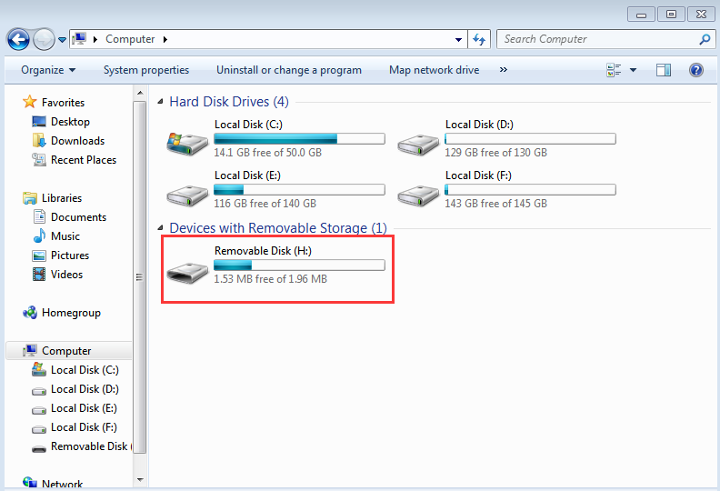

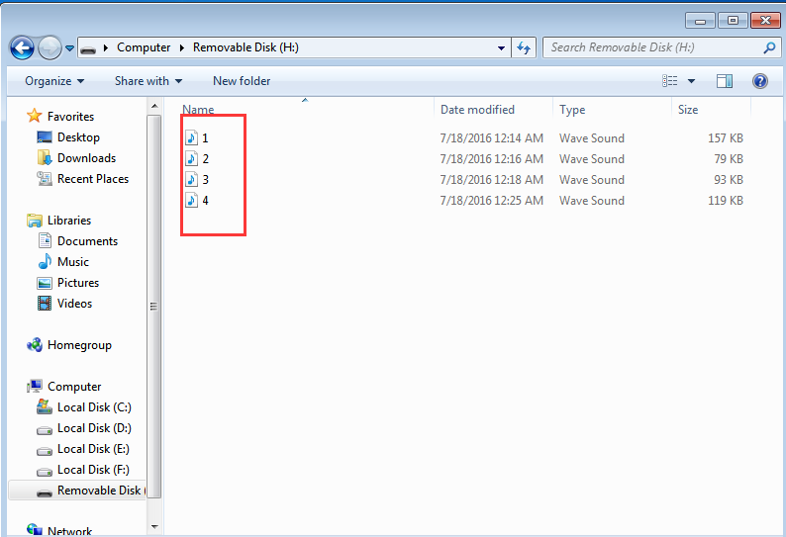
Step 3: Move all your x.wav files from your PC to that Removable Disk (which is your PBX):

Step 4: Unplug micro-usb cable and disconnect your PC from PBX.
Step 5: Enable Automated Attendant mode (see section 3.1)

